# CS 340 README

## About the Project/Project Title

The project aims to create an user interface that will be used to search for a specific criteria of animals that the company needs to train for search-and-rescue training, which provides with them with a usable and interactive interface.

## Motivation

The project makes it easier to sort through a database based on MongoDB, and provides with it a lookup map and chart to show the user the different kinds of animals that are available, which makes it easier to quickly look up any specific type of information that is needed. This can be modified to whatever search criteria is required, and will be highly adaptable to any new databases as required.

## Getting Started

Make sure that python is installed.  
Make sure that the server details in the script are updated.

Username and password are passed as a variable.

Ensure that Dash framework is installed.

## Installation

*List the tools you need to use the software and how to install them.*

*Tools needed: Python, PyMongo, mongodb*

On Debian-based distros, type sudo apt install python, then provide your user password.

On Arch-based distros, type sudo pacman –S python, then provide your user password.

To install PyMongo, use python3 –m pip install pymongo to install PyMongo after installing Python.

To install Dash, pip install dash==0.23.1, pip install dash-renderer==0.13.0, pip install dash-html-components==0.11.0, pip install dash-core-components==0.26.0, pip install plotly==3.1.0

Please refer to MongoDB documentation to install MongoDB, as there is a possibility of instructions used here becoming outdated.

**Required Functionality**

The program is required to display a chart and a map to display data received from the database, and allow for filters to sort through the data and allow for the charts and maps to update and showcase relevant information.

## Usage

The program uses MongoDB in the application to use a schema-less document base, which makes it easier to manage and use in terms of database management when compared to MySQL. The program also uses Dash which provides a useful interface for data visualizations, which is used here to showcase data related to the database.

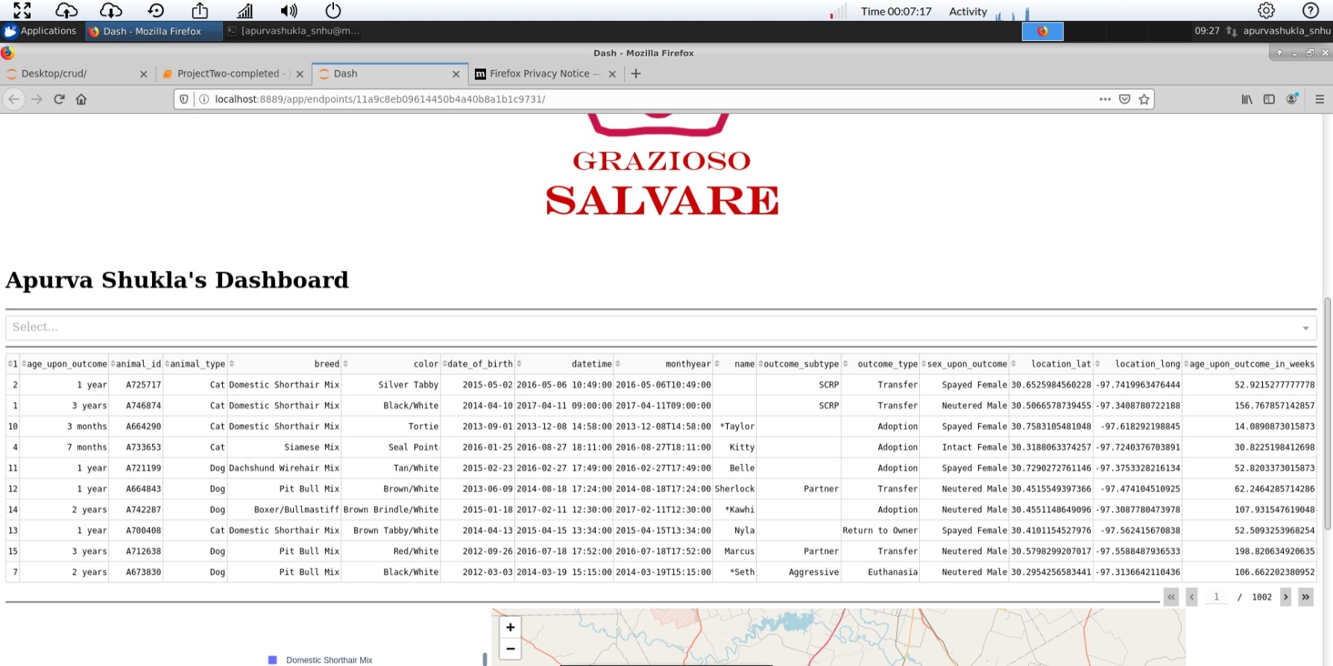

Dashboard proof

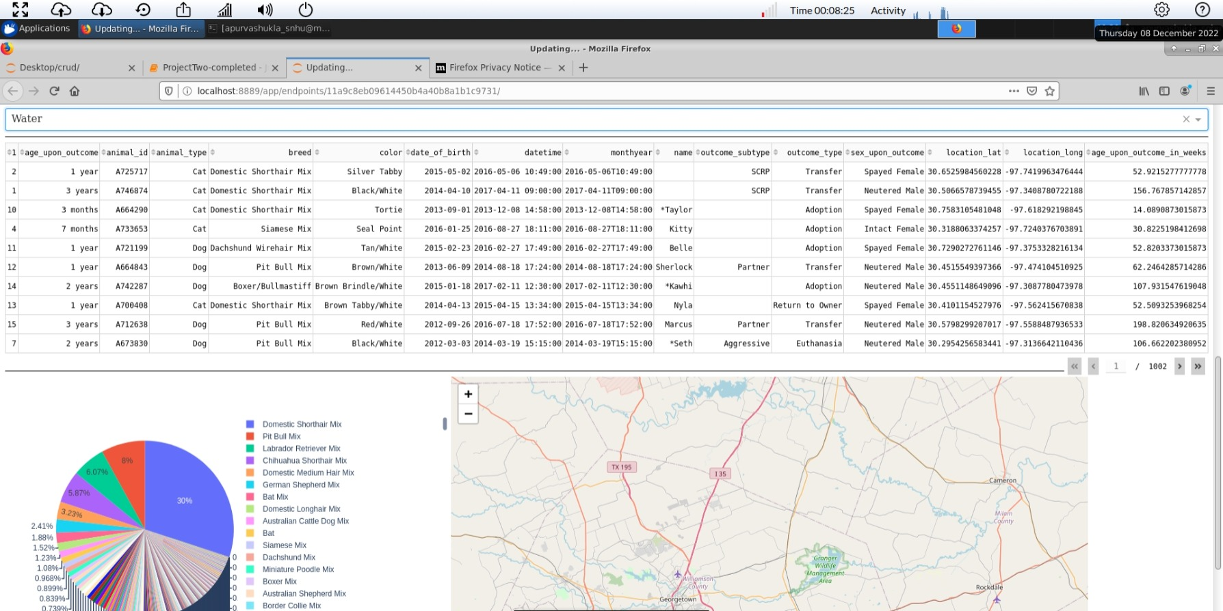

Dashboard for Water filter

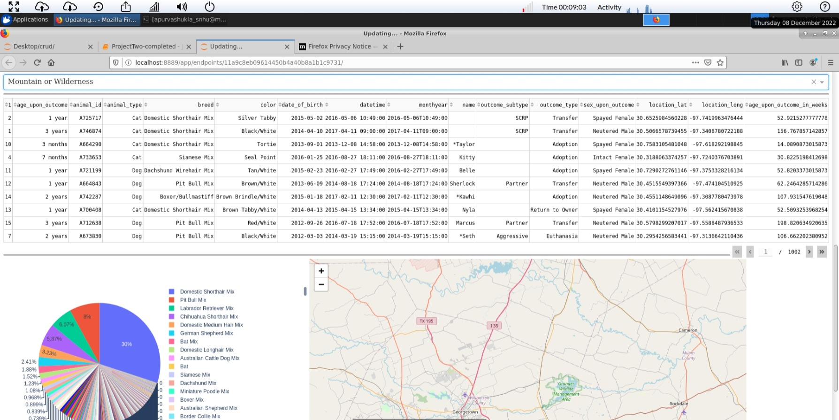

Dashboard for Mountain Filter

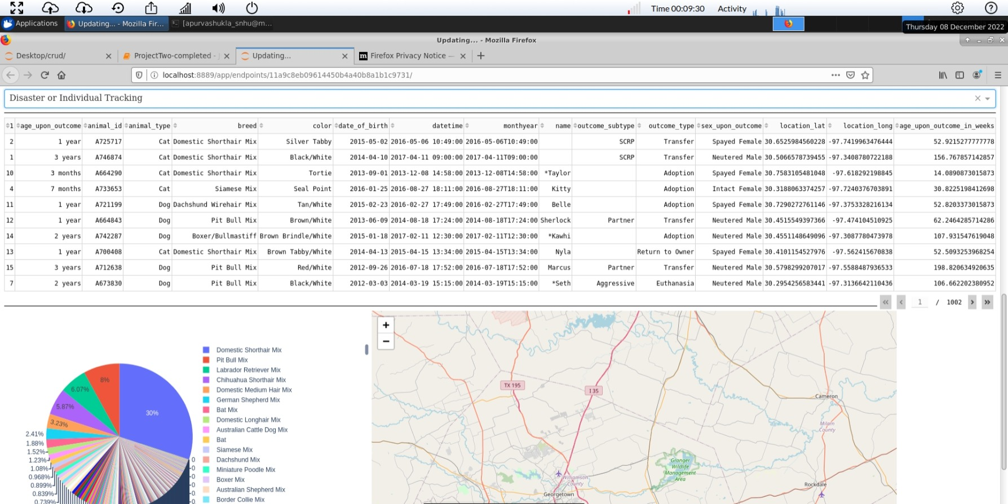

Dashboard for Disaster

### Code Example

def create(self, var):

If data is not None:

dict = self.database.collection.insert(dict)

If dict != 0, return True else return False

### Screenshots

## Contact

Your name: Apurva Shukla